School nursing team at Kenosha County Health Department
Kenosha County Health Department: 262-605-6700

Schools alphabetical

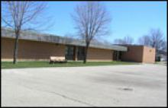  Bose Elementary  1900 15th St  Kenosha, WI 53140  Phone: (262) 359-4044  Fax: (262) 359-4005 | 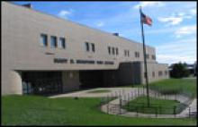  Bradford High School  3700 Washington Rd  Kenosha, WI 53144  Phone: (262) 359-6200  School nurse: (262) 359-6206  Fax: (262) 359-5948 | 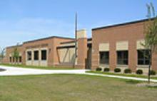  Brass Community School  6400 15th Ave  Kenosha, WI 53143  Phone: (262) 359-8000  Onsite Community Health Center: (262) 359-8008  Fax: (262) 359-8050
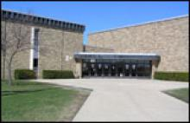  Bullen Middle School  2804 39th Ave  Kenosha, WI 53144  Phone: (262) 359-4460  Fax: (262) 359-4487 | 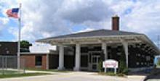  Cesar E. Chavez Learning Station  6300 27th Ave  Kenosha, WI 53143  Phone: (262) 359-6078  Fax: (262) 359-6286 | 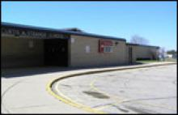  Curtis A. Strange Elementary  5414 49th Ave  Kenosha, WI 53144  Phone: (262) 359-6024  Fax: (262) 359-6247
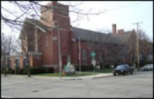  Dimensions of Learning Academy  6218 25th Ave  Kenosha, WI 53143  Phone: (262) 359-6849  Fax: (262) 359-3134 | 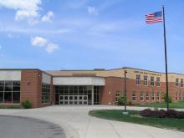  Edward Bain School of Language and Art - Creative Arts  2600 50th St  Kenosha, WI 53140  Phone: (262) 359-2300  Fax: (262) 359-2400 | Edward Bain School of Language and Art - Dual Language  2600 50th St  Kenosha, WI 53140  Phone: (262) 359-2300  Fax: (262) 359-2400
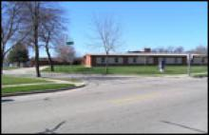  Forest Park Elementary  6810 45th Ave  Kenosha, WI 53142  Phone: (262) 359-6319  Fax: (262) 359-6170 | 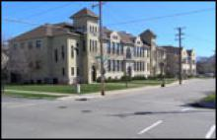  Frank Elementary  1816 57th St  Kenosha, WI 53140  Phone: (262) 359-6324  Fax: (262) 359-6393 | 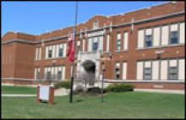  Grant Elementary  1716 35th St  Kenosha, WI 53140  Phone: (262) 359-6346  Fax: 262-953-6672
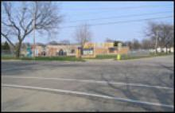  Grewenow Elementary  7714 20th Ave  Kenosha, WI 53143  Phone: (262) 359-6362  Fax: (262)359-7706 | 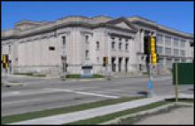  Harborside Academy  913 57th Street  Kenosha, WI 53140  Phone: (262) 359-8400  Fax: (262) 359-8450 | 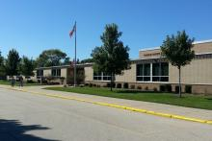  Harvey Elementary  2012 19th Ave  Kenosha, WI 53140  Phone: (262) 359-4040  Fax: (262) 359-4020
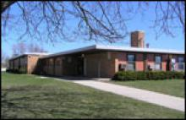  Hillcrest School  4616 24th St  Kenosha, WI 53144  Phone: (262) 359-6118  Fax: (262) 359-7870 | 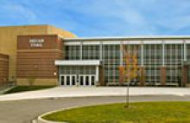  Indian Trail High School and Academy  6800 60th St  Kenosha, WI 53144  Phone: (262) 359-8700  School nurse: Call main number  Fax: (262) 359-8756 | 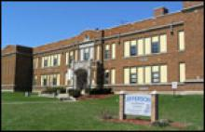  Jefferson Elementary  1832 43rd St  Kenosha, WI 53140  Phone: (262) 359-6390  Fax: (262) 359-7578
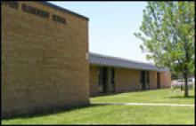  Jeffery Elementary  4011 87th St  Kenosha, WI 53142  Phone: (262) 359-2100  Fax: (262) 359-2033 | Kenosha eSchool  1808 41st Place  Kenosha, WI 53140  Phone Number: (262) 359-7715  Fax: (262) 359-5933 | 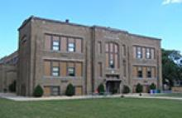  Kenosha School of Technology Enhanced Curriculum (KTEC) - East  6811 18th Ave  Kenosha, WI 53143  Phone: (262) 359-3800  Fax: (262) 359-3850
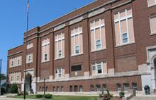  Kenosha School of Technology Enhanced Curriculum (KTEC) - West  5710 32nd Ave  Kenosha, WI 53144  Phone: (262) 359-7100  Fax: (262) 359-7070 | 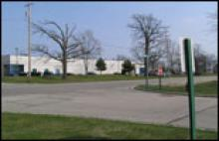  LakeView Technology Academy  9449 88th Ave  Pleasant Prairie, WI 53158  Phone: (262) 359-8155  Fax: (262) 359-8159 | 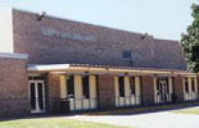  Lance Middle School  4515 80th St  Kenosha, WI 53142  Phone: (262) 359-2240  Fax: (262) 359-2184
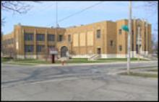  Lincoln Middle School  6729 18th Ave  Kenosha, WI 53143  Phone: (262) 359-6296  Fax: (262) 359-5966 | 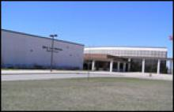  Mahone Middle School  6900 60th St  Kenosha, WI 53144  Phone: (262) 359-8100  Fax: (262) 359-6851 | 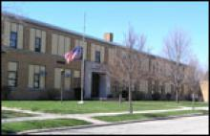  McKinley Elementary  5520 32nd Ave  Kenosha, WI 53144  Phone: (262) 359-6002  Fax: (262) 359-7641
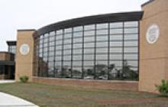  Nash Elementary  6801 99th Ave  Kenosha, WI 53142  Phone: (262) 359-3500  Fax: (262) 359-3550 | 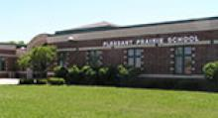  Pleasant Prairie Elementary  9208 Wilmot Rd  Pleasant Prairie, WI 53158  Phone: (262) 359-2104  Fax: (262) 359-2157 | 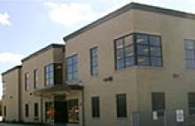  Prairie Lane Elementary  10717 47th Ave  Pleasant Prairie, WI 53158  Phone: (262) 359-3600  Fax: (262) 359-3650
Reuther Central High School  913 57th St  Kenosha, WI 53140  Phone: (262) 359-6160  Fax: (262) 359-6281 | 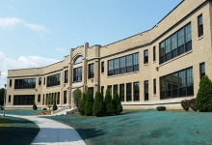  Roosevelt Elementary  3322 Roosevelt Rd  Kenosha, WI 53142  Phone: (262) 359-6097  Fax: (262) 359-6107 | 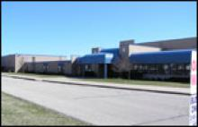  Somers Elementary  1245 72nd Ave  Kenosha, WI 53144  Phone: (262) 359-3200  Fax: (262)-359-3212
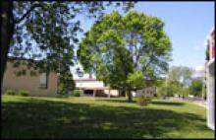  Southport Elementary  723 76th St  Kenosha, WI 53143  Phone: (262) 359-6309  Fax: (262) 359-5952 | 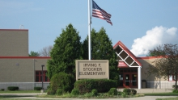  Stocker Elementary  6315 67th St  Kenosha, WI 53142  Phone: (262) 359-2143  Fax: (262) 359-2012 | 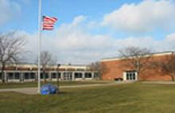  Tremper High School  8560 26th Ave  Kenosha, WI 53143  Phone: (262) 359-2200  School nurse: (262) 359-2233  Fax: (262)-359-2353
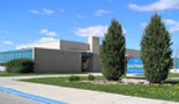  The Brompton School  8518 22nd Ave  Kenosha, WI 53143  Phone: (262) 359-2191  Fax: (262) 359-2194 | Vernon Elementary  8518 22nd Ave  Kenosha, WI 53143  Phone: (262) 359-2113  Fax: (262) 359-2169 | 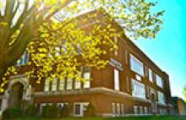  Washington Middle School  811 Washington Rd  Kenosha, WI 53140  Phone: (262) 359-6291  Fax: (262) 359-6056
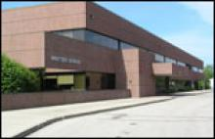  Whittier Elementary  8542 Cooper Rd  Pleasant Prairie, WI 53158  Phone: (262) 359-2110  Fax: (262) 359-2270 | 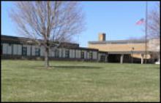  Wilson Elementary  4520 33rd Ave  Kenosha, WI 53144  Phone: (262) 359-6094  Fax: (262) 359-5993

