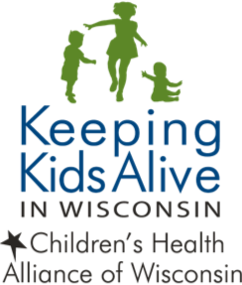

Interagency Agreement

This cooperative agreement is made this _____________ day of ______________________ between each of the following agencies:

______________________________________________________________________________________
Office of the Medical Examiner/Coroner

______________________________________________________________________________________
County Child Protective Services

______________________________________________________________________________________
Office of the Prosecuting Attorney

______________________________________________________________________________________
Sheriff’s Department

______________________________________________________________________________________Police Department

______________________________________________________________________________________County Health Department

______________________________________________________________________________________List Others as Needed

WHEREAS, the parties agree they are mutually served by the establishment of a multi-agency, multi-disciplinary Child Death Review (CDR) or Fetal Infant Mortality (FIMR) team, and the outcomes of the reviews will be the identification of preventable infant and child deaths and recommendations for interventions and prevention strategies.

WHEREAS, the objectives of a CDR and FIMR team are:
1. Comprehensive and timely identification, review and data entry of sudden and unexpected infant and child deaths with special emphasis on causes with potential preventability.
2. Vested with the authority to promote and protect the public health and safety and to provide services which will improve the well-being of children and their families through improved communication and coordination of community responses to infant and child deaths, particularly delivery of services before and/or after the incident.
3. Identification of needed changes in legislation, policy and practices, and expanded efforts in child health and safety to prevent future deaths.
WHEREAS, the parties agree all members signing this agreement are essential to an effective case review.

WHEREAS, the parties agree the review process requires case specific sharing of information; and that confidentiality is inherent in many of the involved reports, requiring that no case review will occur without all present abiding by the confidentiality agreement.

NOW THEREFORE, it is agreed that all team members and others present at a fatality review will sign a confidentiality agreement which prohibits any dissemination of information beyond the purpose of the review process. The review team will not create any files with identifying data. Case information will be utilized to enlist inter-agency cooperation in the case reviews, delivery of services and development of prevention recommendations. It is further understood that a particular agency may be asked to take the lead in addressing a systemic or quality of care concern based on the agency’s clear connection with the incident. It is further understood that a participating agency may use information obtained at the review in accordance with the mandated responsibilities of that agency as required or permitted by law. Identifiable information entered into the National Fatality Case Reporting System (CRS) is removed from the national database. At the national level, the case reports entered into the CRS are de-identified.

