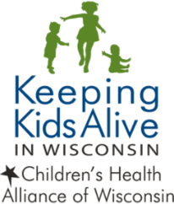

Case Review Confidentiality Form

Case Initials _________________ Date _____________________

The (Insert County Name) County Child Death Review (CDR) Team exists to conduct a thorough review of infant and child deaths in (Insert County Name) County in order to better understand the circumstances and risk factors surrounding unexpected infant and child deaths; and to take actionable steps to prevent future deaths.

The Right of Confidentiality will be respected by team members participating in the review process. Each agency representative and invited guest is responsible for maintaining the confidentiality of the information shared and discussed as required by Wisconsin Law. In addition, each team member and invited guest is expected to comply with his or her professional ethics and refrain from sharing information outside of the fatality review process/meeting. The disclosure of confidential information is permitted only to the extent allowed and or required by law and professional responsibilities.

As an (Insert County Name) County CDR Team member or invited guest, I agree that I will not disclose or disseminate confidential information to which I gained access as a part of the case review process. I understand that I may be subject to civil or criminal penalties if I improperly release information obtained during the review process.

Signature Printed Name Agency

